Passive Walking Rimless Wheel

This article focuses on the dynamic’s equation of motion derivation of the walking of a rimless wheel speeding under influence of its own weight under gravity on an inclined plane as shown in the figure below.



Figure . Rimless wheel motion under effect of its own weight at an inclined plane

In above figure, *γ* is the inclination angle of the slope.

Rimless wheel parameters are defined as follows:

1. m: Mass of the hub (center)
2. *l* : Length of each spoke
3. *ge* : g * cos(gamma) is Effective gravity along slope
4. *mw* : Mass per spoke
5. *lw* : Distance of spoke CoM from hub
6. *n* : Number of spokes
7. *rw* : Distance of the CoM of the spoke from rotating spoke foot

For the geometry of spokes, the angle between the spokes can be simply written as: ϕ = 2*pi/n

Distance of CoM of each spoke from the center of rotation (fixed leg on the ground) can be estimated employing the cosine rule as depicted in the figure below.



Also, the angle with the fixed leg and the line joining the CoM each leg can be estimated as:



The velocity of the hub and individual spokes can be estimated from the rotation velocity as:



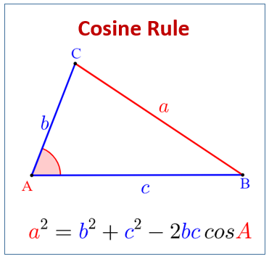

Figure : Cosine rule

We use Euler-Lagrange formulation to identify the dynamics here. The kinematic energy of the system can be estimated as:



Similarly, the potential energy of the system can be estimated as follows:



Using Euler-Lagrange formulation:



**Leg Switching**

We employ the concept of conservation of the momentum to find the angle and angular velocity value changes after the impact on the ground.



Figure : Leg impact and switching from one to another

When another leg touches the ground, the rotation point shifts to that leg and previous leg is now free to rotate in the air. In such case, assuming the collision is to be conservative (i.e. no energy is being lost), we conserve the momentum before and after the collision.

Before impact, the wheel is rotating about the old contact point. To apply angular momentum conservation at the new contact point, we shift the reference point to the new contact point.

